

IMPLEMENTING CRM FOR RESULT TRACKING OF A CANDIDATE WITH INTERNAL MARKS

Project Report

1.INTRODUCTION **page no**

1.1 Overview 02

1.2 Purpose 02

2.Problem Definition & Design Thinking

2.1 Empathy Map 03

2.2 Ideation & Brainstorming Map 05

3.RESULT

3.1 Data Model 09

3.2 Activity & Screenshot 10

4.Trailhead Profile Public URL 20

5.ADVANTAGES&DISADVANTAGES 21

6.APPLICATIONS 23

7.CONCLUSION 24

8.FUTURE SCOPE 25



**1.INTRODUCTION**

1.1 Overview

Implementing a CRM (Customer Relationship Management) system for result tracking of a candidate with internal marks is a process of utilizing software tools to manage and monitor a candidate's academic progress and results. The system collects and stores data such as personal information, academic records, and internal marks. This data can then be analyzed and reported to provide insights into the candidate's performance and progress.

The CRM system can provide features such as alerts for upcoming exams, notifications for low grades, and automated communication with teachers or counselors. These features help the candidate stay on track and receive support when needed.

1.2 Purpose

The purpose of implementing a CRM (Customer Relationship Management) system for result tracking of a candidate with internal marks is to streamline the process of managing and monitoring academic progress. The system helps to collect and store data related to the candidate's academic records and internal marks, which can be analyzed to provide insights into their performance and progress.

By implementing a CRM system for result tracking, the candidate's academic progress can be monitored more effectively, facilitating communication between the candidate, teachers, and counselors. The system can also provide features such as alerts for upcoming exams, notifications for low grades, and automated communication with teachers or counselors. This helps to ensure that the candidate stays on track and receives the necessary support to succeed.

**2.Problem Definition & Design Thinking**

2.1 Empathy Map

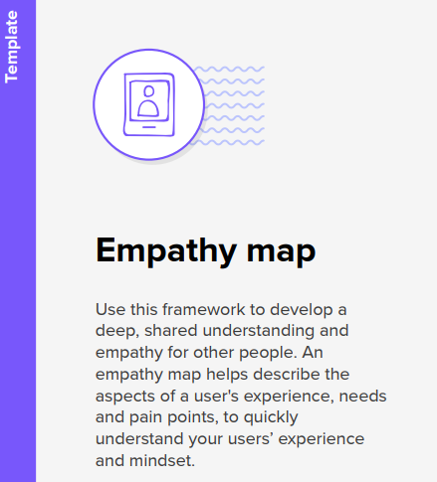

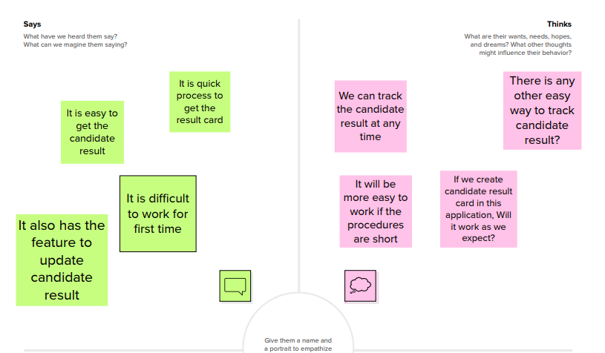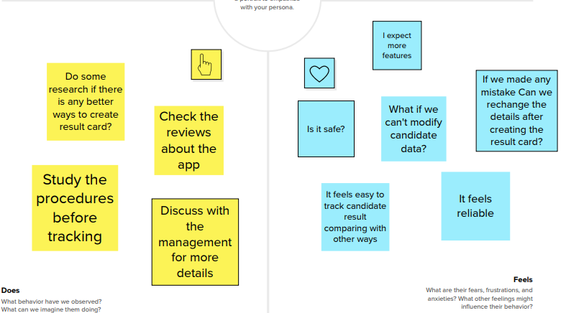

Implementing CRM for result tracking of a candidate with internal marks

Implementing CRM for result tracking of a candidate with internal marks

2.2 Ideation & Brainstorming Map

|  |
| --- |
|  |

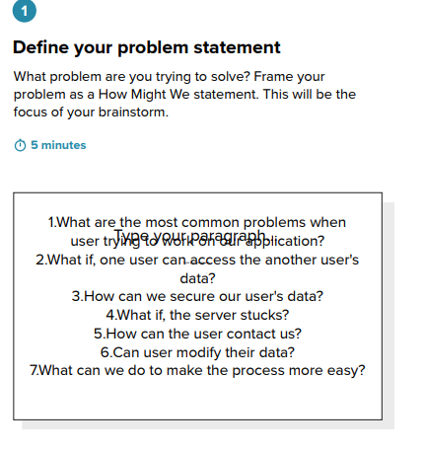

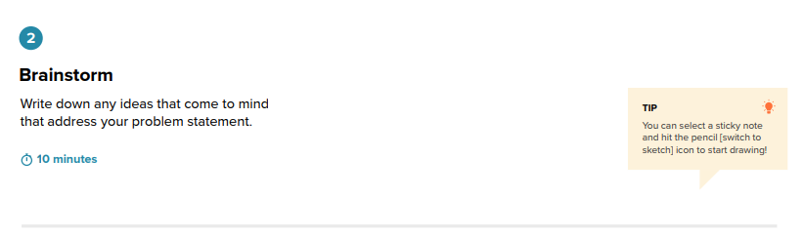

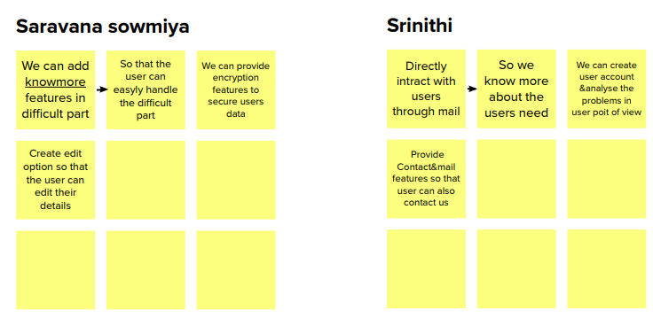 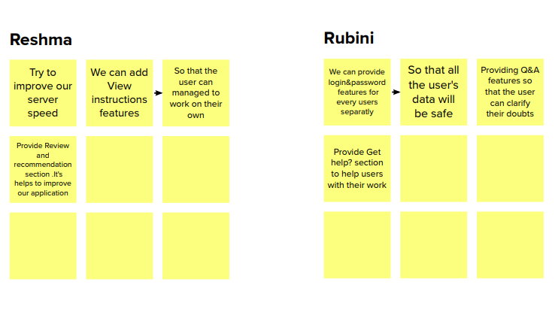

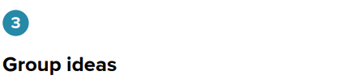

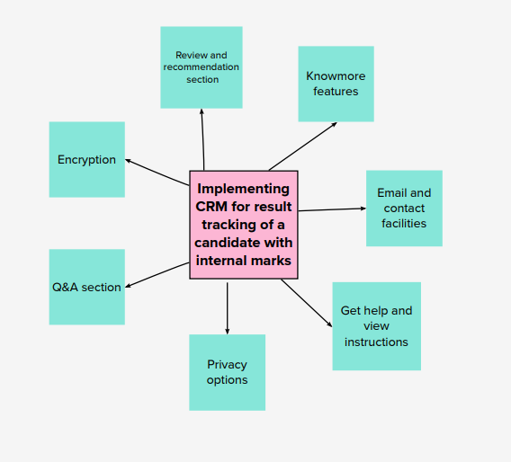

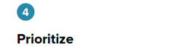

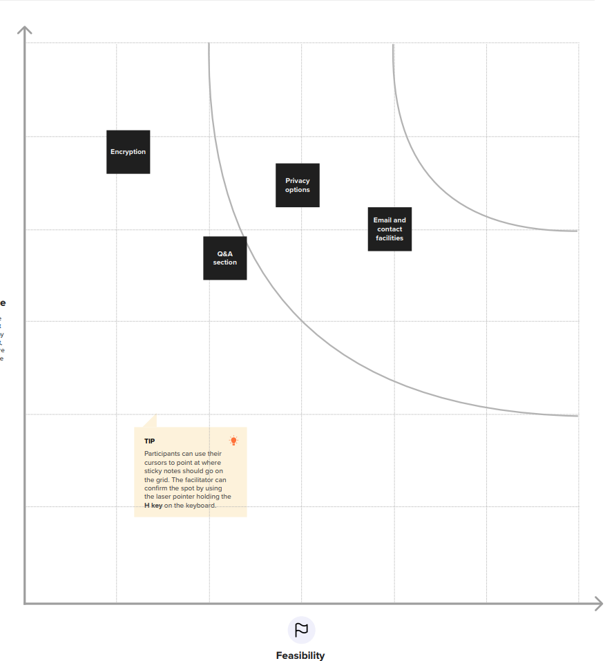

**3.RESULT**

3.1 Data Model:

|  |  |
| --- | --- |
| **Object name** | **Fields in the Object** |
| Semester | |  |  | | --- | --- | | Field label | Data type | | Created by | Lookup(User) | | Last Date modified by | Lookup(User) | | Owner | Lookup(User, Group) | | Semester Name | Text(15) | | Semester Name | Text(80) | |
| Candidate | |  |  | | --- | --- | | Field label | Data type | | Candidate Name | Text(15) | | Candidate Name | Text(80) | | Created by | Lookup(User) | | Last Date modified by | Lookup(User) | | Owner | Lookup(User, Group) | |
| Course Details | |  |  | | --- | --- | | Field label | Data type | | Course details name | Text(80) | | Course name | Text(15) | | Created by | Lookup(User) | | Last Date modified by | Lookup(User) | | Owner | Lookup(User, Group) | |

|  |  |
| --- | --- |
| **Object name** | **Fields in the Object** |
| Lecturer Details | |  |  | | --- | --- | | Field label | Data type | | Created by | Lookup(User) | | Last Date modified by | Lookup(User) | | Lecturer detail name | Text(80) | | Lecturer Role | Text(15) | | Owner | Lookup(User, Group) | |
| Internal results | |  |  | | --- | --- | | Field label | Data type | | Candidate ID | Text(15) | | Created by | Lookup(User) | | Internal result name | Text(80) | | Last Date modified by | Lookup(User) | | Owner | Lookup(User, Group) | |

3.2 Activity & Screenshot

***Milestone 1: Creation Salesforce Org:***

**Activity 1: Creating Developer Account**

Go to **developers.salesforce.com/** .Click on sign up. On the sign up form, enter the following details :

First name & Last name , Email , Role : Developer , Company : College Name , County : India ,Postal Code : pin code , Username : should be a combination of your name and company. This need not be an actual email id, you can give anything in the format : [username@organization.com](mailto:username@organization.com).

Click on sign up after filling these.

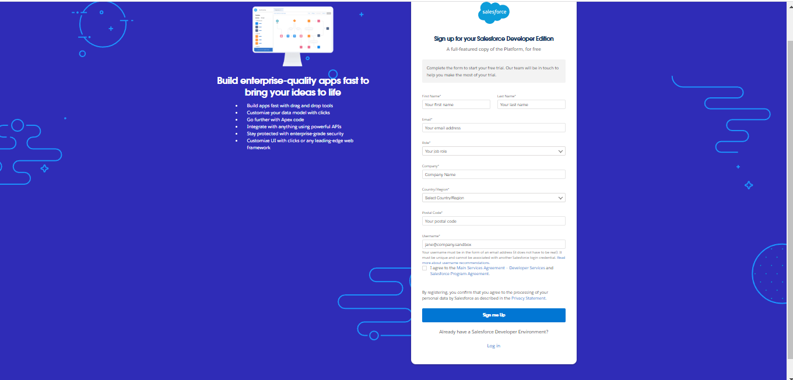

**Account Activation**

Go to the inbox of the email that you used while signing up. Click on the verify account to activate your account. The email may take 5-10mins, as

**Login To Your Salesforce Account**

Go to salesforce.com and click on login. Enter the username and password that you just created.

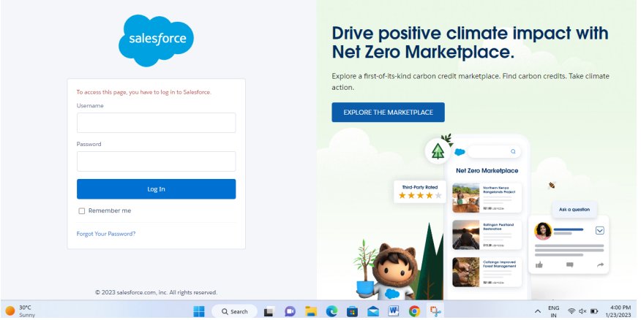

After login this is the home page which you will see.

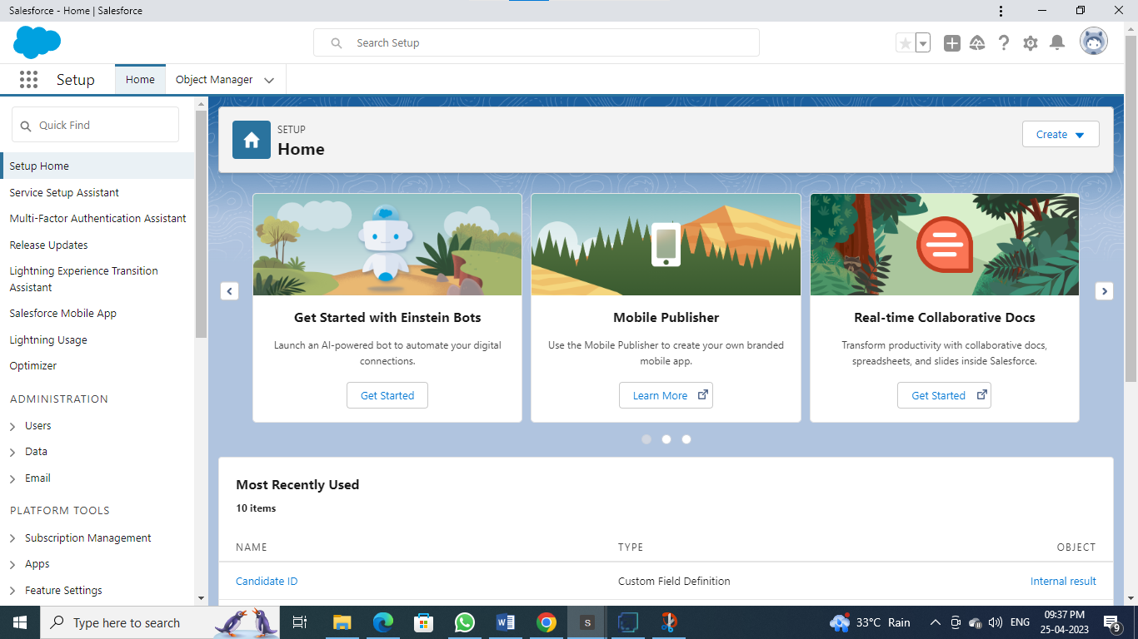

***Milestone-2:Object***

***Custom objects:***

1.Semester 2.Candidate 3.Course Details 4.Lecturer Details 5.Internal results

***Activity-1: To Create an object:***

Creation of Objects for Candidate Internal Result Card, For this Candidate Internal Result Card we need to create 5 objects

i.e Semester,Candidate,Course Details,Lecturer Details,Internal Results.

To Navigate to Setup page: Click on gear icon → click setup.

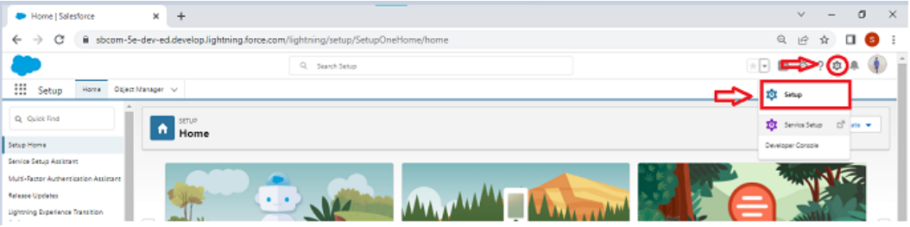

To create an object: From the setup page → Click on Object Manager → Click on Create → Click on Custom Object

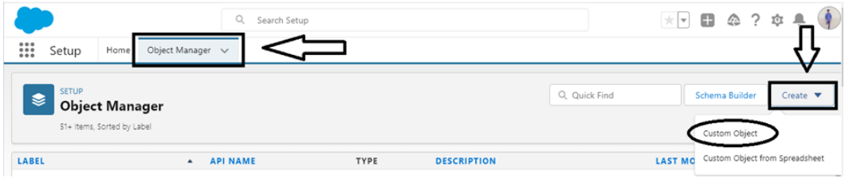

On Custom object defining page: Enter the label name, plural label name, click on Allow reports, Allow search → Save.

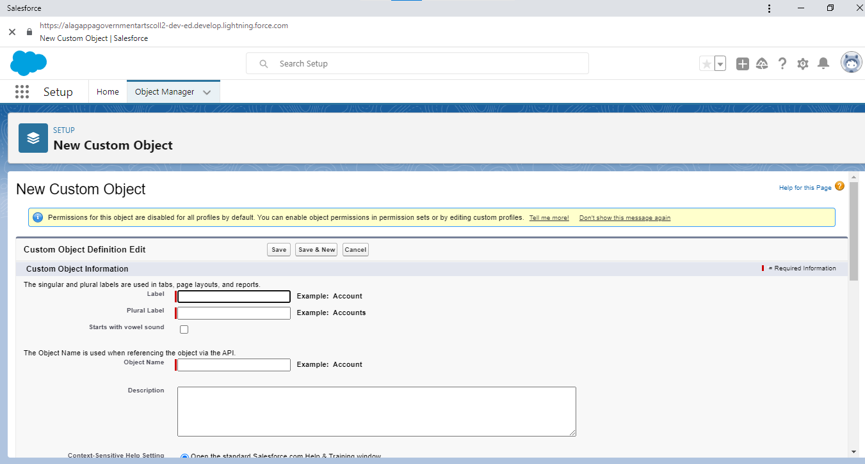

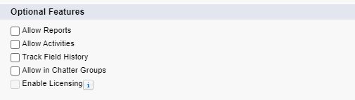

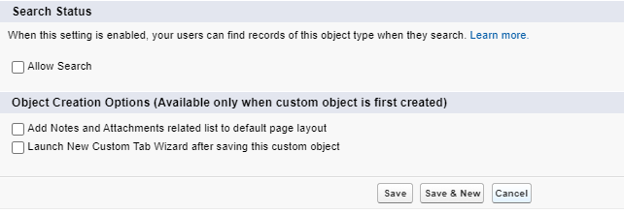

***Activity-2***

Follow Similar steps to create Candidate,Course Details,Lecturer Details,Internal results Objects.

***Milestone -2: Fields and Relationship***

**Activity-1: Creation of fields:**

To create fields in an object: Go to setup → click on Object Manager → type object name in search bar → click on the object.

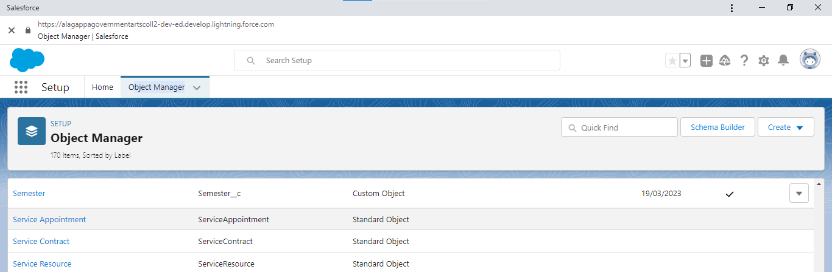

Now click on “Fields & Relationships” → New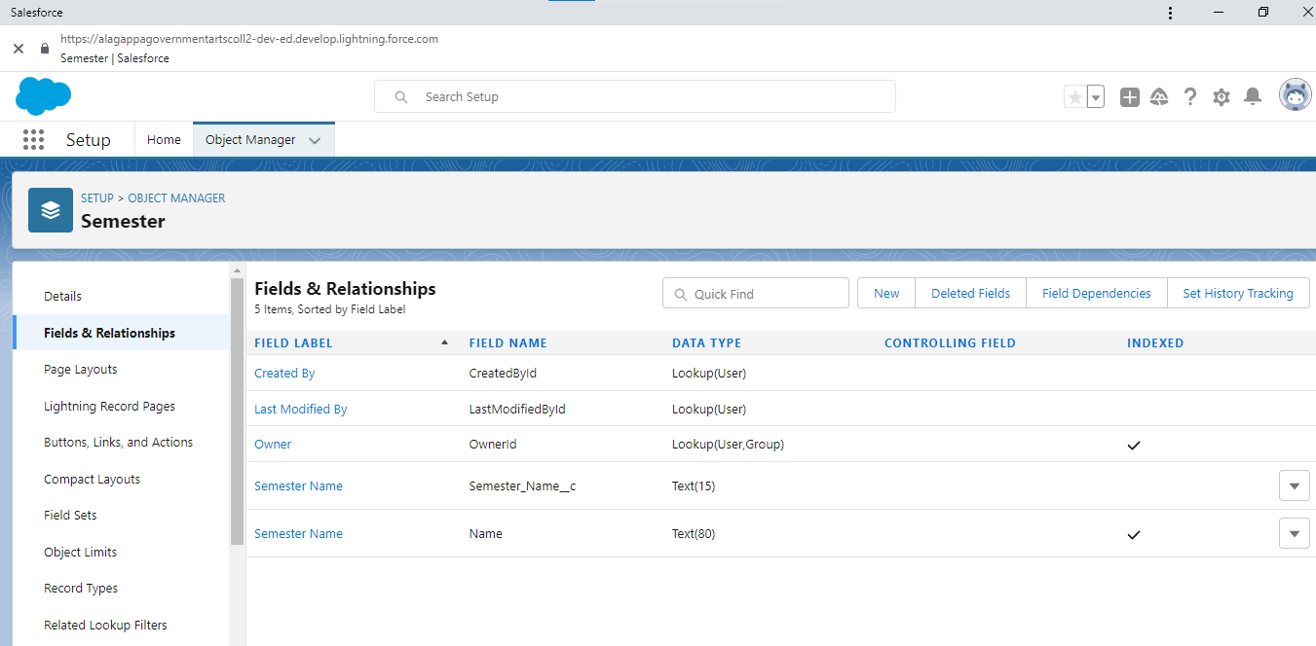

Fill the field label name → Next → Next → Save.

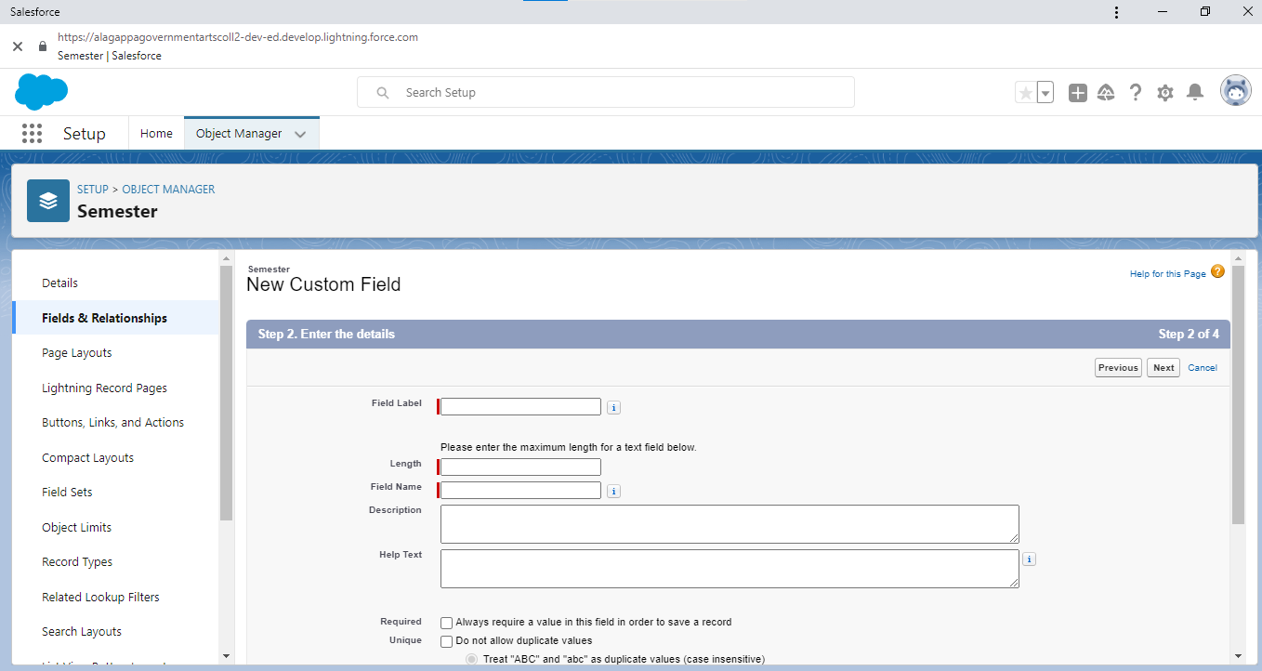

***Activity-2:***

Similarly Create Following Fields according to the objects.

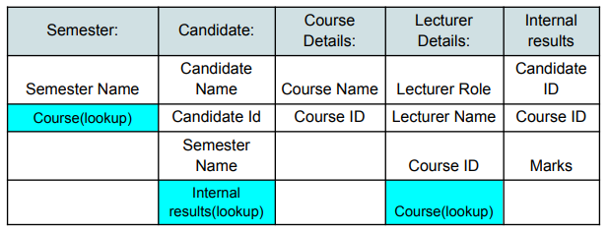

***Milestone-3:Lightning App***

Apps in Salesforce are a group of tabs that help the application function by working together as a unit. It has a name, a logo, and a particular set of tabs. The simplest app usually has just two tabs.

***Activity-1:***

***Create the Candidate Internal Result Card app:***

To create a lightning app page:

Go to setup page → search “app manager” in quick find → select “app manager” → click on New lightning App.

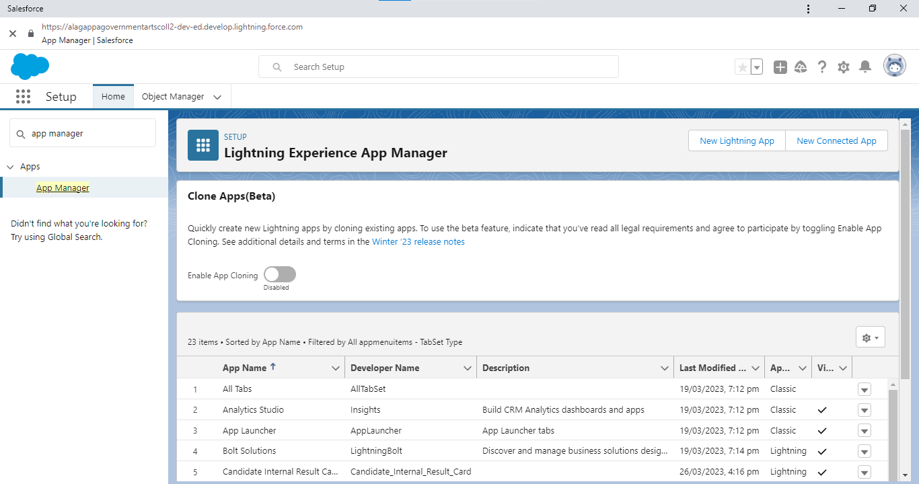

Fill the app name in app details and branding →Next → (App option page) keep it as default → Next → (Utility Items) keep it as default → Next → (Add Navigation Items) → Next → (Add User Profile) Add System Administrator → Next.

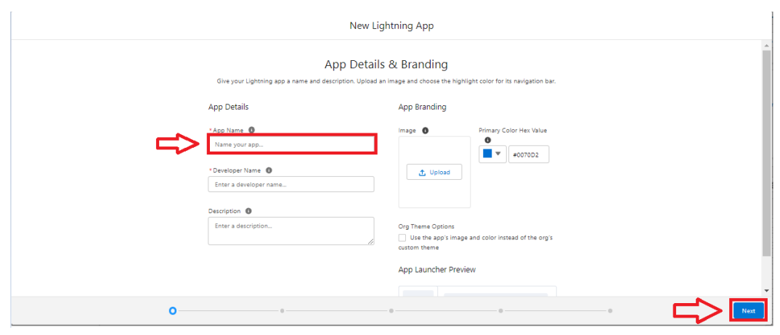

To Add Navigation Items: Select the items from the search bar and move it using the arrow button → Next.

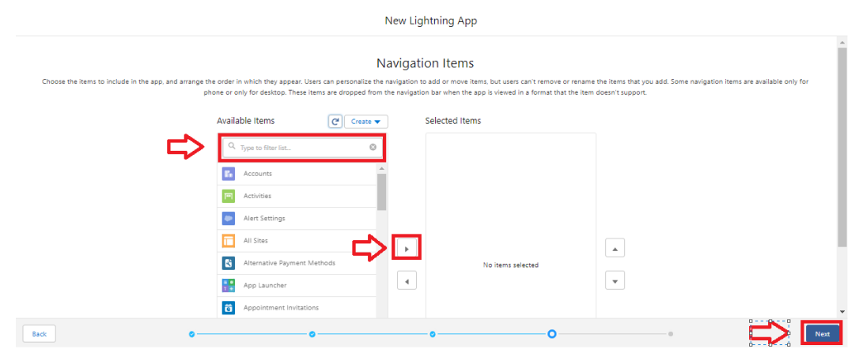

To Add User Profiles:

Search profiles in search bar → click on the arrow button → save & finish.

***Milestone-4: Users***

***Activity 1: Creating a Users:***

1. From Setup, in the Quick Find box, enter Users, and then select Users.

2. Click New User.

3. Enter the user’s name John Martin and (Your) email address and a unique username in the form of an email address. By default, the username is the same as the email address.

4. Select a Role(none)

5. Select a User Licence As salesforce.

6. Select a profile as Salesforce User.

7. Check Generate new password and notify the user immediately to have the user’s login name and a temporary password emailed to your email.

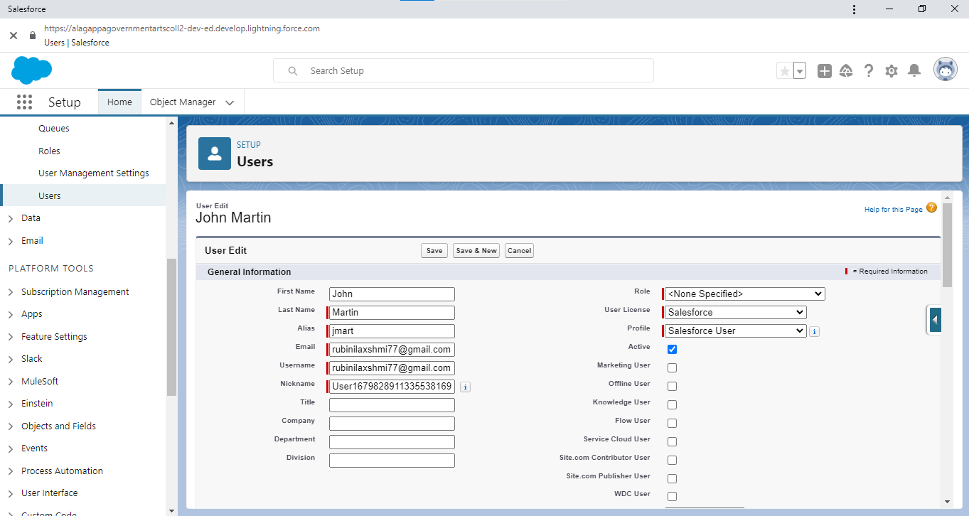

***Milestone-5: Reports***

***Activity 1:***

***Reports and dashboards:***

To create a report:

Go to the app → click on the reports tab.

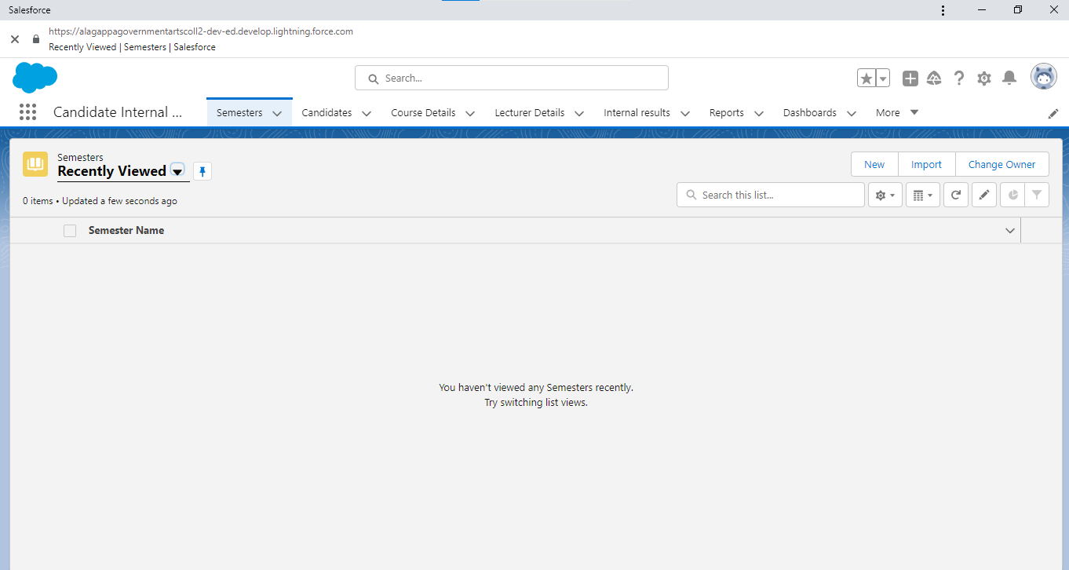

Click New Report

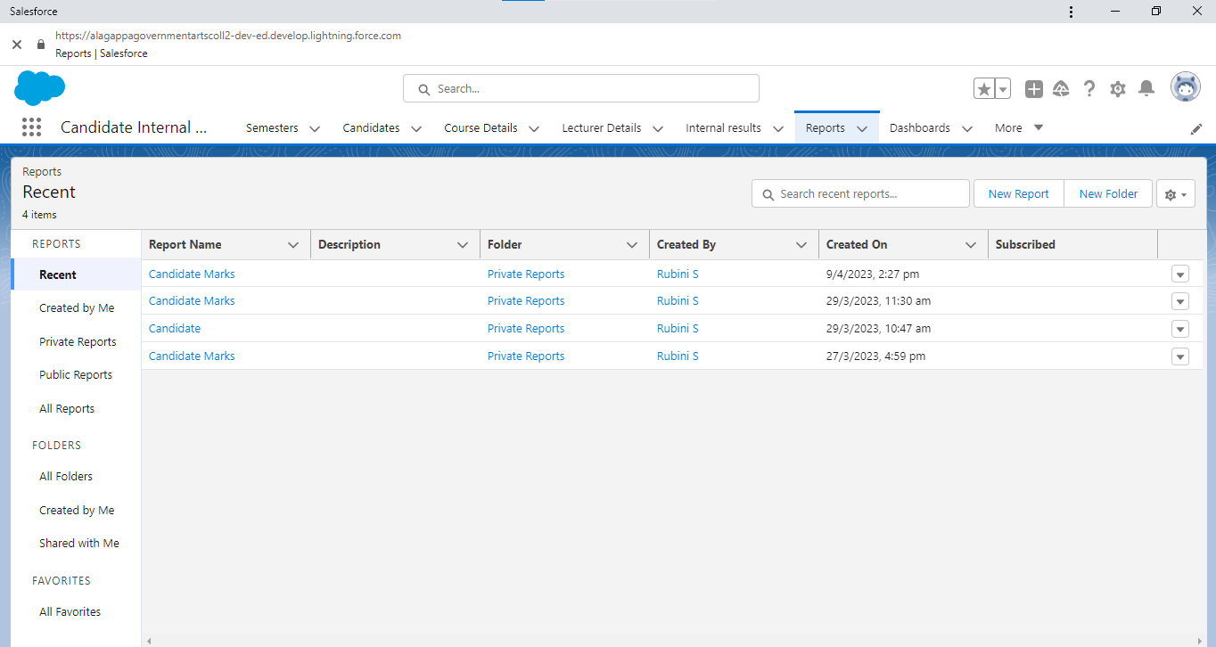

Select report type from category or from report type panel or from search panel → click on start report.

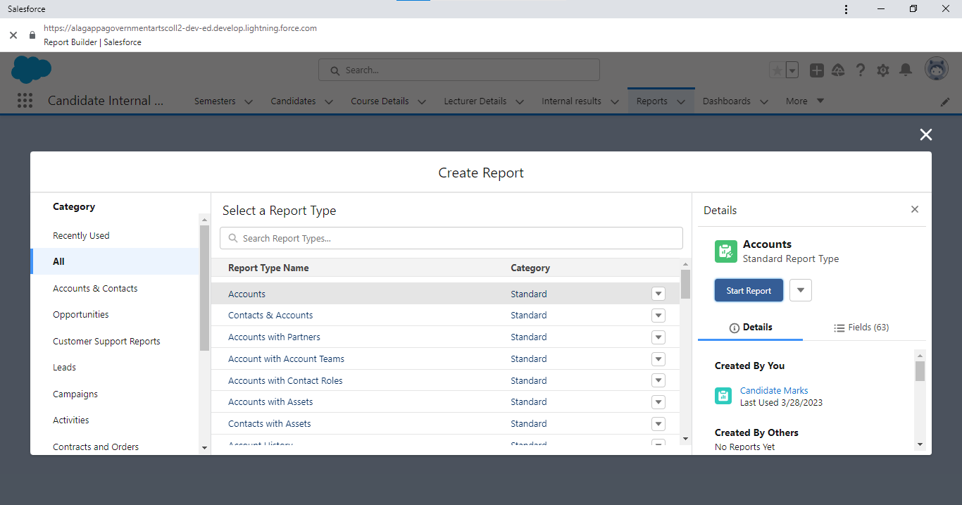

Customize your report, then save or run it.

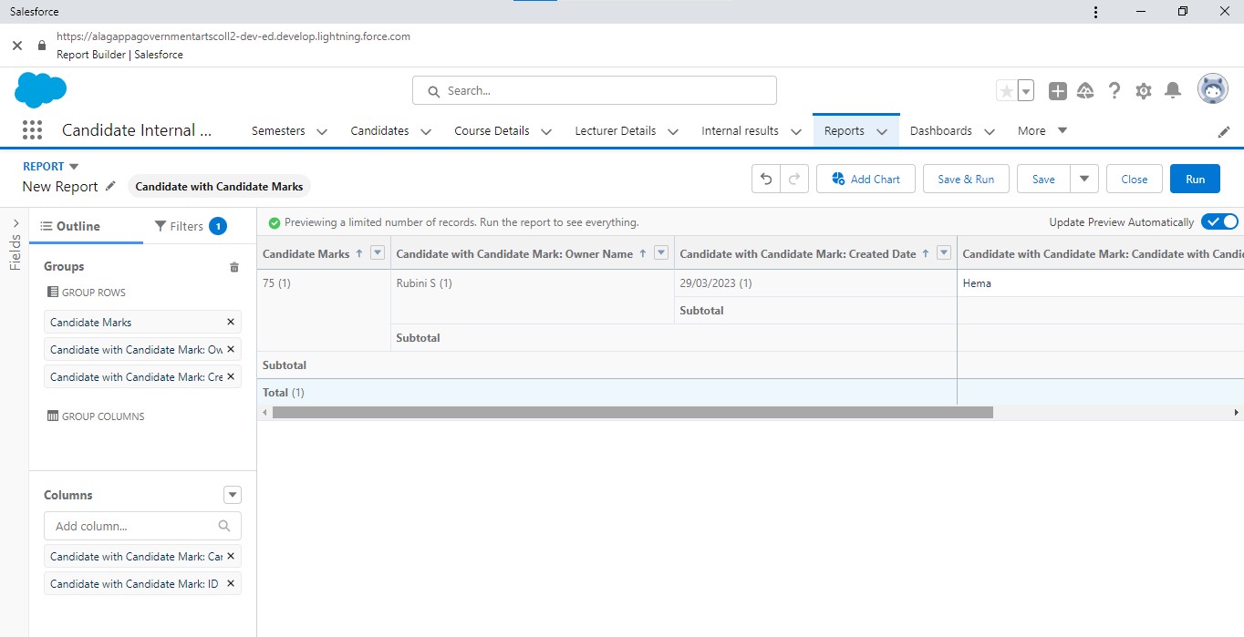

***Milestone-6: Dashboards:***

***Activity 1: Create a Dashboard:***

1. Click the Dashboards tab.

2. Click New Dashboard.

3. Name your dashboard Candidate Board . Leave all other fields as is and click Create.

4. Click + Component.

5. For Report, select Candidate Marksby Stage. Click Select. ...

6. For Display As, select Vertical Bar Chart and click Add.

7. Click Save.

8. Click Done.

**4.Trailhead Profile Public URL**

Team Lead - <https://trailblazer.me/id/rubinilakshmi77>

Team Member 1 - <https://trailblazer.me/id/reshma2705>

Team Member 2 - <https://trailblazer.me/id/saravanasowmiya05>

Team Member 3 - <https://trailblazer.me/id/srinithi2508>

***5. ADVANTAGES & DISADVANTAGES:***

Implementing a CRM (Customer Relationship Management) system for result tracking of a candidate with internal marks can have both advantages and disadvantages. Some of these are:

Advantages:

1. Improved Data Management: A CRM system can help to centralize all the data related to the candidate's internal marks, making it easier to manage and track the progress of the candidate.

2. Increased Efficiency: Automating the tracking process through a CRM system can reduce manual effort and improve the overall efficiency of the tracking process.

3. Personalized Communication: A CRM system can allow personalized communication with the candidate, providing a more engaging and interactive experience.

4. Better Analytics: A CRM system can help to generate reports and analytics based on the data, providing insights that can help to improve the overall tracking process.

5. Enhanced Collaboration: A CRM system can allow multiple stakeholders, such as teachers, parents, and administrators, to collaborate and share information about the candidate's progress.

Disadvantages:

1. Implementation Cost: Implementing a CRM system can be expensive, and may require additional hardware or software.

2. Technical Expertise: A CRM system may require technical expertise to set up and maintain, which could be a challenge for some organizations.

3. Training: Staff may need training on how to use the CRM system effectively, which could be time-consuming and add additional costs.

4. Data Privacy Concerns: A CRM system could be vulnerable to data breaches, which could compromise the privacy of candidate data.

5. Integration Challenges: Integrating the CRM system with other systems or software used in the organization could be challenging, leading to compatibility issues.

Overall, implementing a CRM system for result tracking of a candidate with internal marks can provide significant benefits in terms of data management, efficiency, and communication. However, organizations should carefully weigh the costs and potential drawbacks before deciding to implement a CRM system.

***6.APPLICATIONS***

Implementing a CRM (Customer Relationship Management) system for result tracking of a candidate with internal marks can have several applications that can benefit educational institutions, students, and other stakeholders involved in the process. Some of these applications include:

1. Improved Candidate Experience: A CRM system can help educational institutions provide a personalized experience to the candidates by providing access to their internal marks, progress reports, and other relevant information in real-time. This can enhance the candidate experience and help them stay informed about their academic progress.

2. Better Communication: A CRM system can help educational institutions communicate with candidates in a more efficient and effective manner. It can facilitate two-way communication and allow candidates to ask questions or share concerns with teachers and other stakeholders.

3. Streamlined Admissions Process: By tracking candidate internal marks using a CRM system, educational institutions can streamline their admissions process. They can quickly access a candidate's internal marks and use this information to make informed decisions about admissions.

4. Enhanced Teaching and Learning: By tracking candidate internal marks using a CRM system, teachers can gain insights into the performance of each candidate. They can use this information to tailor their teaching methods and provide individualized support to each candidate.

5. Improved Resource Allocation: A CRM system can help educational institutions allocate resources more efficiently. They can use the data collected to identify candidates who require additional support and allocate resources accordingly.

6. Better Collaboration: A CRM system can help stakeholders collaborate more effectively. Teachers, parents, and administrators can share information about candidates in real-time, making it easier to provide support and make informed decisions.

Overall, implementing a CRM system for result tracking of a candidate with internal marks can have several applications that can benefit educational institutions, candidates, and other stakeholders. It can enhance the candidate experience, improve communication, streamline the admissions process, enhance teaching and learning, improve resource allocation, and promote collaboration.

***7.CONCLUSION***

In conclusion, implementing a CRM (Customer Relationship Management) system for result tracking of a candidate with internal marks can provide numerous benefits to educational institutions, candidates, and other stakeholders involved in the process. It can improve data management, increase efficiency, provide personalized communication, and offer better analytics. It can also enhance the candidate experience, streamline the admissions process, promote collaboration, and allocate resources more efficiently.

However, there are also potential challenges that need to be considered, such as implementation costs, technical expertise, data privacy concerns,

training requirements, and integration challenges. Educational institutions should carefully evaluate these potential challenges and weigh them against the benefits of implementing a CRM system.

Overall, if implemented correctly, a CRM system can significantly improve the tracking and monitoring of candidate internal marks, and help educational institutions provide better support and resources to candidates. It can help to enhance the overall educational experience and contribute to the long-term success of both the candidates and the educational institutions.

***8. FUTURE SCOPE***

The future scope of implementing a CRM (Customer Relationship Management) system for result tracking of a candidate with internal marks is promising, with several potential advancements and opportunities on the horizon. Some of these include:

1. Artificial Intelligence and Machine Learning: The integration of artificial intelligence (AI) and machine learning (ML) algorithms in CRM systems can provide more accurate and real-time data analysis, leading to improved decision-making, and personalized insights for each candidate.

2. Enhanced Data Privacy and Security: With the increasing focus on data privacy and security, CRM systems can be designed with more robust security measures to ensure the protection of candidate data.

3. Mobile Integration: The integration of mobile technology can allow candidates to access their internal marks, progress reports, and other information through their mobile devices, making the process more convenient and accessible.

4. Cloud-Based Infrastructure: Cloud-based CRM systems can provide greater scalability and flexibility, allowing educational institutions to access data from any location and manage large volumes of data more efficiently.

5. Integrated Learning Management Systems: The integration of CRM systems with Learning Management Systems (LMS) can provide a more comprehensive view of candidate performance, leading to improved decision-making and personalized support.

6. Predictive Analytics: The integration of predictive analytics can help educational institutions anticipate candidate needs and preferences, leading to more effective communication and resource allocation.

Overall, the future scope of implementing a CRM system for result tracking of a candidate with internal marks is promising, with several potential advancements that can help educational institutions provide better support and resources to candidates. These advancements can lead to more efficient and effective tracking and monitoring of candidate internal marks, and ultimately contribute to better educational outcomes for all stakeholders involved.